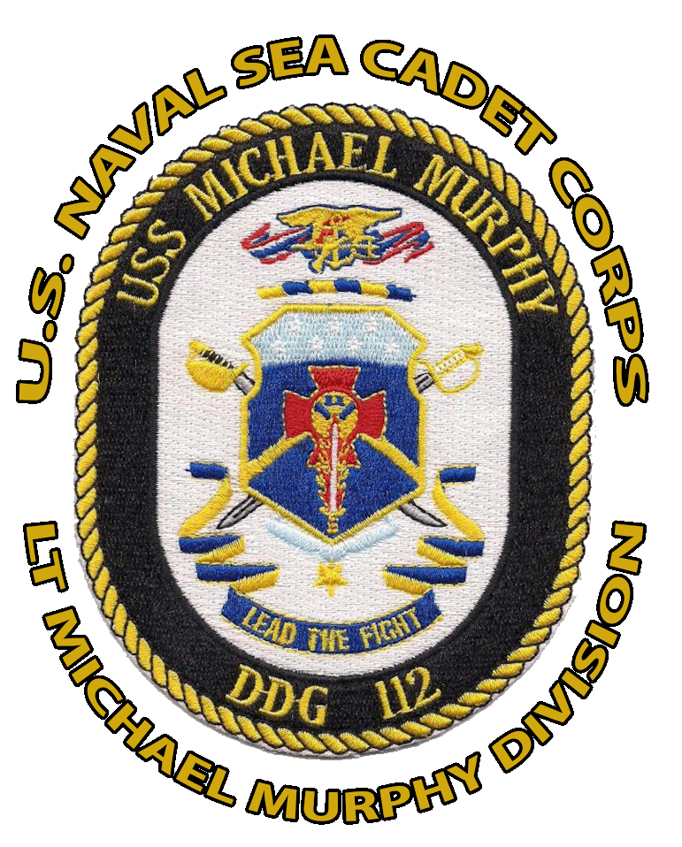
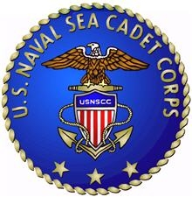
USNSCC
LT MICHAEL P. MURPHY DIVISION
034MUR

You are cordially invited
to attend the
LT Michael Murphy Division’s
Departing Cadet Graduation
&
Promotion Ceremony for
Cadet Leadership

United States Naval
Sea Cadet Corps

Sunday, June 12, 2016
at 10:00 a.m.
Long Island Maritime Museum

Light refreshments will be served

